**LABORATORIO 3.2**

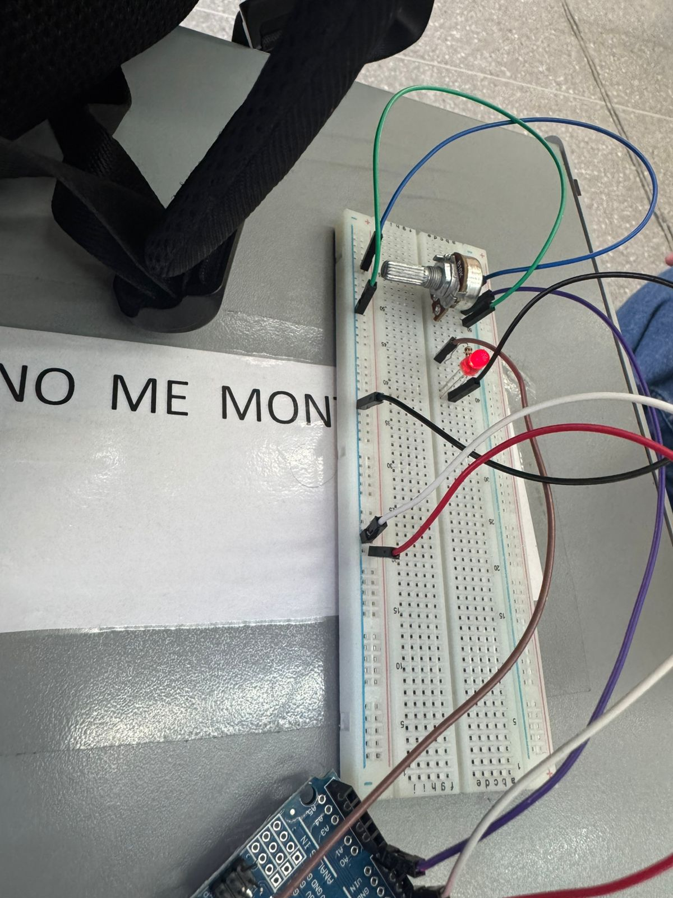

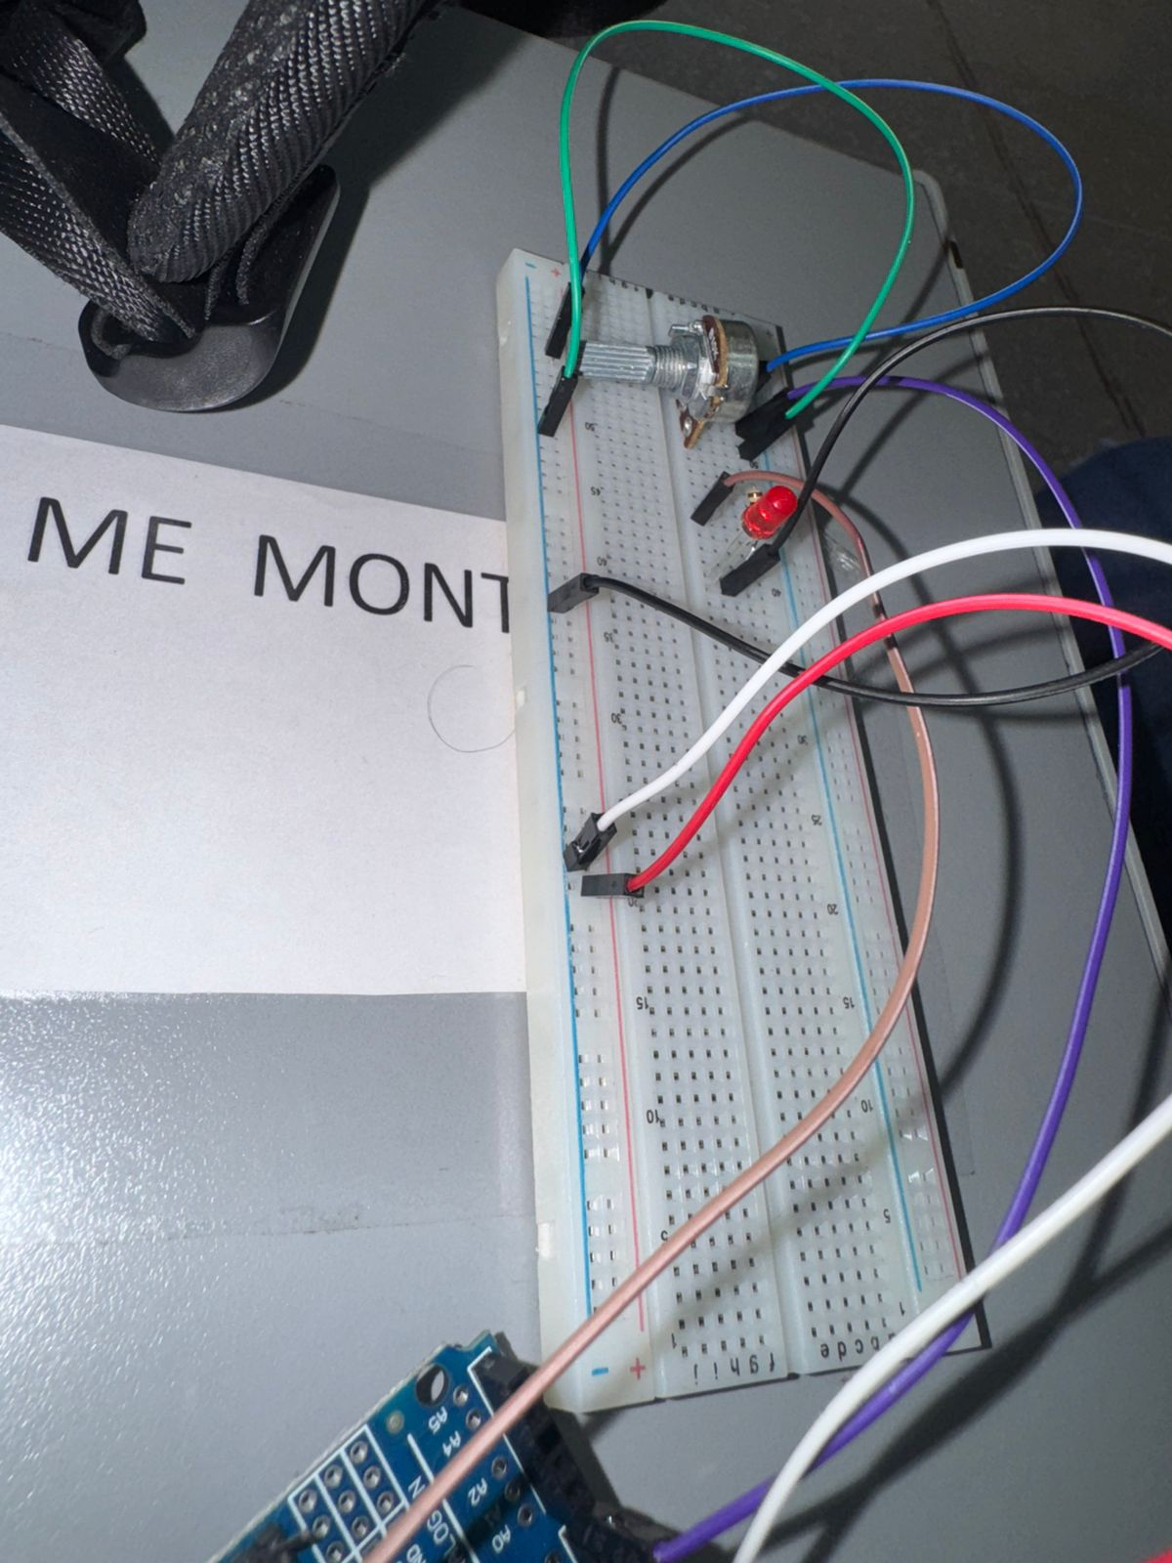

**Link de Tinkercad**

**https://www.tinkercad.com/things/lnntbJ2yya9-sizzling-jofo?sharecode=xQlptovcaT04bd4VlaiwCBtNaW9EWc75PLpU6--Td54**